 | The Story of  ‘Freedom for All’’  Through Music and Art  Residency and Symphony Concert | 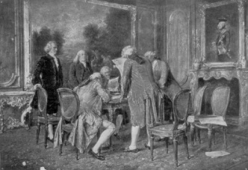  Who  George Washington  Henry Knox  Johnny Appleseed  William Bartram  Andrew Jackson  Henry Flagler  13 Colonies/States  British  Ulster-Scots  New Learnings:  Fifes  Penny Whistles  Instruments of Symphony  Conductor  Conservationist  Illustrator  New Understandings:  Civic Responsibility  Archetype of hero  Freedom  Collaboration  Diversity  Life Applications:  How we treat one another  Appreciating our differences  The strength of Diversity  FL: 14th and 15th British colonies  FL: Land of many people  Johnny Appleseed  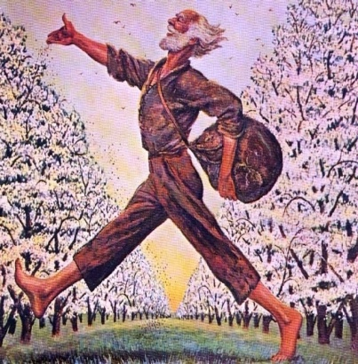  Andrew Jackson  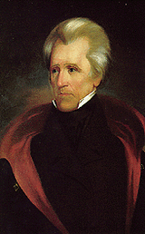  Marjorie Kinnan Rawlings  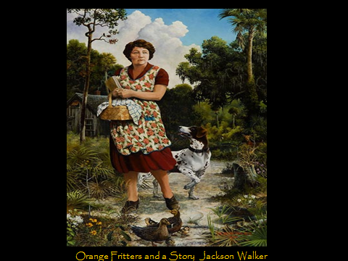  William Bartram  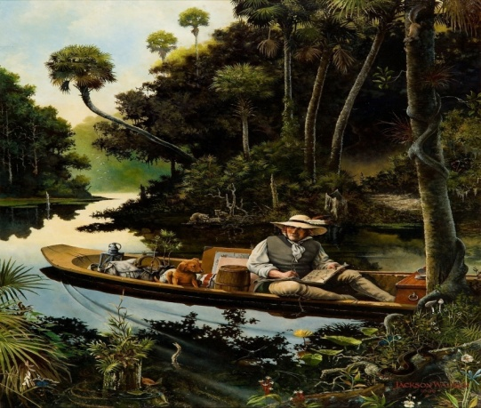  School Residency and  Culminating Experience with  Symphony Orchestra  Music of:  Jeremy Ribando  Robert Kerr  Aaron Copland  Art:  Jackson Walker  Norman Rockwell

Quick Guide Grades 1-5
www.donnawissinger.com
Donna: email topformdrw@aol.com or call 407-492-8876

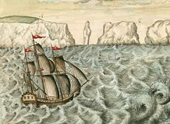
Music and art turn the pages of American history for students and teachers. It begins with freedom: students feel the call of fife and drum and march into an understanding of the American Revolutionary War. They sail into the adventure of crossing oceans to learn of immigrants who risked everything for freedom and who helped to form this great land. Students continue their journey of America by learning of people who, with their freedom, wrote their best life stories. Students learn the dates, events, and personalities that have shaped their country, The United States of America. Students learn of the responsibility of each citizen to keep America true to her word that ‘All people are created equal’.

History is a subject about people who dared to live their lives courageously. It illuminates their triumphs, their shortcomings, and the unknown consequences of their actions.
We can learn how to better write our own life stories by knowing theirs.

Figures for Very Young Citizens-Grades 1-2
George Washington: Commander in Chief; First President
Johnny Appleseed: Adventurer and model of a person writing their life story
Bobby Fife: A young boy who came to American for freedom

Important Figures for Young Citizens-Grades 3-5
Henry Knox: Chief of Artillery for George Washington
William Bartram: Early conservationist
Andrew Jackson: Important General in Florida history; Seventh President
Marjorie Kinnan Rawlings: Pulitzer Prize winner for ‘The Yearling’
Norman Rockwell: Great American illustrator
Henry Flagler: Built an ‘impossible’ railroad and opened the door to FL

Beginning in 1765 with the Stamp Act, some people in the 13 British colonies of North America became angry with their British King. They became even angrier in 1770 after the Boston Massacre in which some colonists were killed by British Soldiers. A group of colonists in Boston called the Sons of Liberty spread talk of independence and freedom. They staged a Tea Party in Boston Harbor to protest British laws. By 1775 colonists were ready to stand up for their rights. When British General Gage ordered British troops to march out of Boston to capture ammunition stored by the Patriots, a single shot changed the course of history. Through the Declaration of Independence in 1776, a new country was fighting for its life. They were fighting for freedom, for a place where all people would know they were created equal and common ordinary people would govern themselves.
Character Traits that created the United States and Florida
- Courage to explore 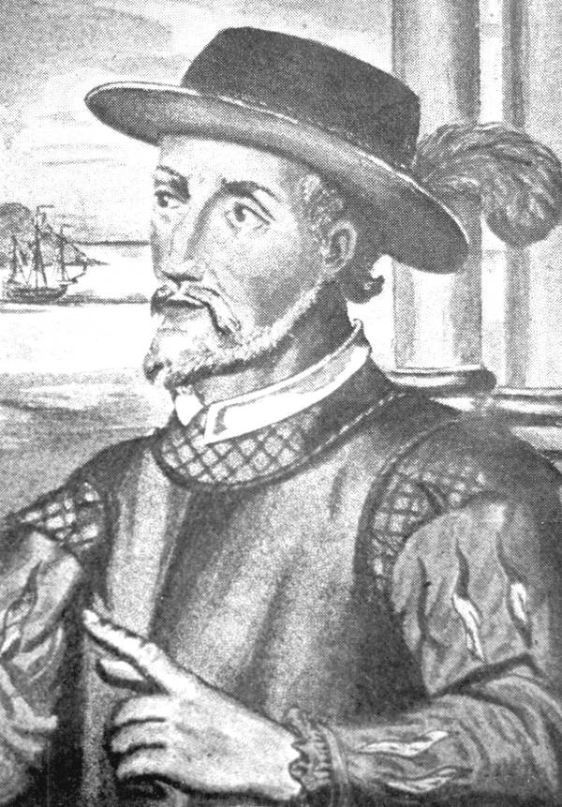
- Tenacity to persevere hardships for beliefs 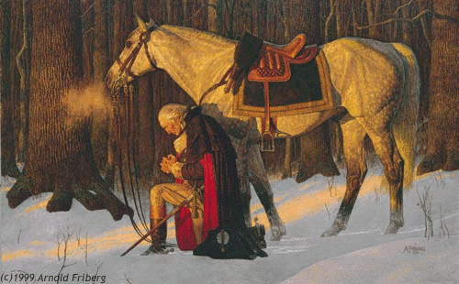
- Dedication to preserving natural beauty 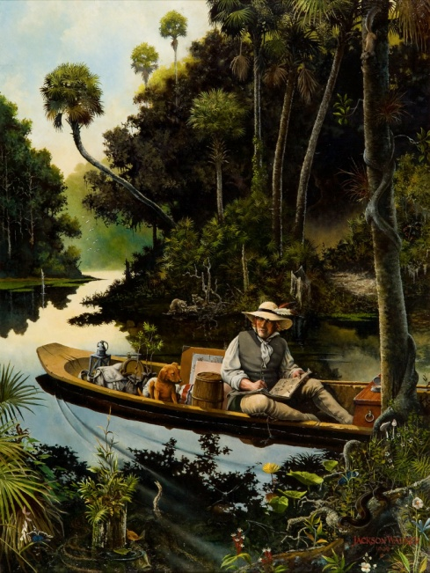
- Willingness to risk failure 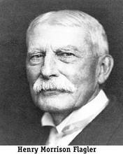 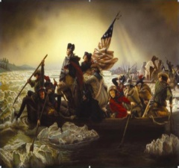



Declaration of Independence
We hold these truths to be self-evident. That all men are created equal, that they are endowed by their Creator with certain unalienable rights, that among these are life, liberty and the pursuit of happiness.

Example of Sunshine State Standards met during residency and orchestra program:
- SS.A.4.2.3 Events leading to and including American Revolution
- SS.A.4.2.4 All aspects of war and resulting documents
- MU.A.3.2.3; MU.C.1.2.3; MU,E.1.2.2 Rhythm, meter, lyrics, MU.4.C.1.1 Identify and classify instrument families of orchestral
- MU.4.C.3.1 Describe what makes a musical work appealing
- MU.4.H.2 Describe how arts document historical events
- MU.4.H.3 Learn connections between learning music and learning other subject

