 | Tales of Legendary Florida: 500 Years of History Through Music and Art | 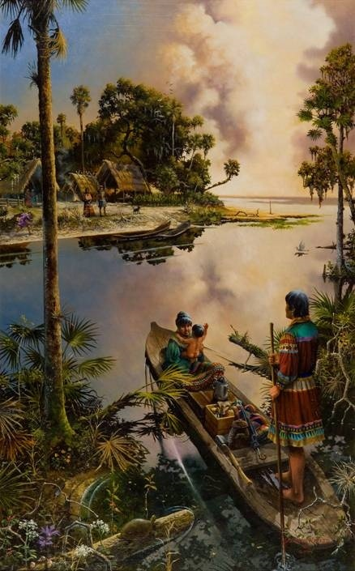  Who  Ponce de Leon  300 Strong  William Bartram  Andrew Jackson  Henry Flagler  Marjorie K Rawlings  Calusa  Timucua  Apalachee  Spanish  English  French  13 Colonies/States  Spanish: Land in FL in 1513; Search for Fountain of Youth and Gold: Settled St. Augustine: Oldest City  French: Settled west and north of FL and briefly captured Pensacola  English: Take Possession of FL after the French and Indian War, 1763  Establish West Florida, Capitol Pensacola and East Florida, Capitol St. Augustine  14th and 15th British colonies  France: Joined the war on the side of the Colonies  Spain: Joined the war on the side of the Colonies  Florida returns to Spain after the Revolutionary War  Florida’s Amelia Island flew under the flags of 4 different nations in the 1800’s  In 1821, Florida becomes part of the United States  William Pope Duval: Governor of Territory of Florida  Tallahassee new Capitol  Seminole Wars ended in 1842  Florida becomes 27th State in 1845  William Dunn Moseley-First  Governor of FL 1845-1849  Florida secedes from Union  Biggest battle on Florida soil:  Olustee  Spain 1513; 1565-1763; 1784-1821  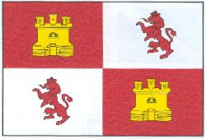  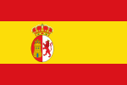  France 1565-1763  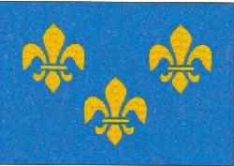  England 1763-1784  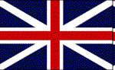  Confederate1861-1865  

Symphony Orchestra Guide Grades 3-8
www.donnawissinger.com email:topformdrw@aol.com Donna: 407-492-8876

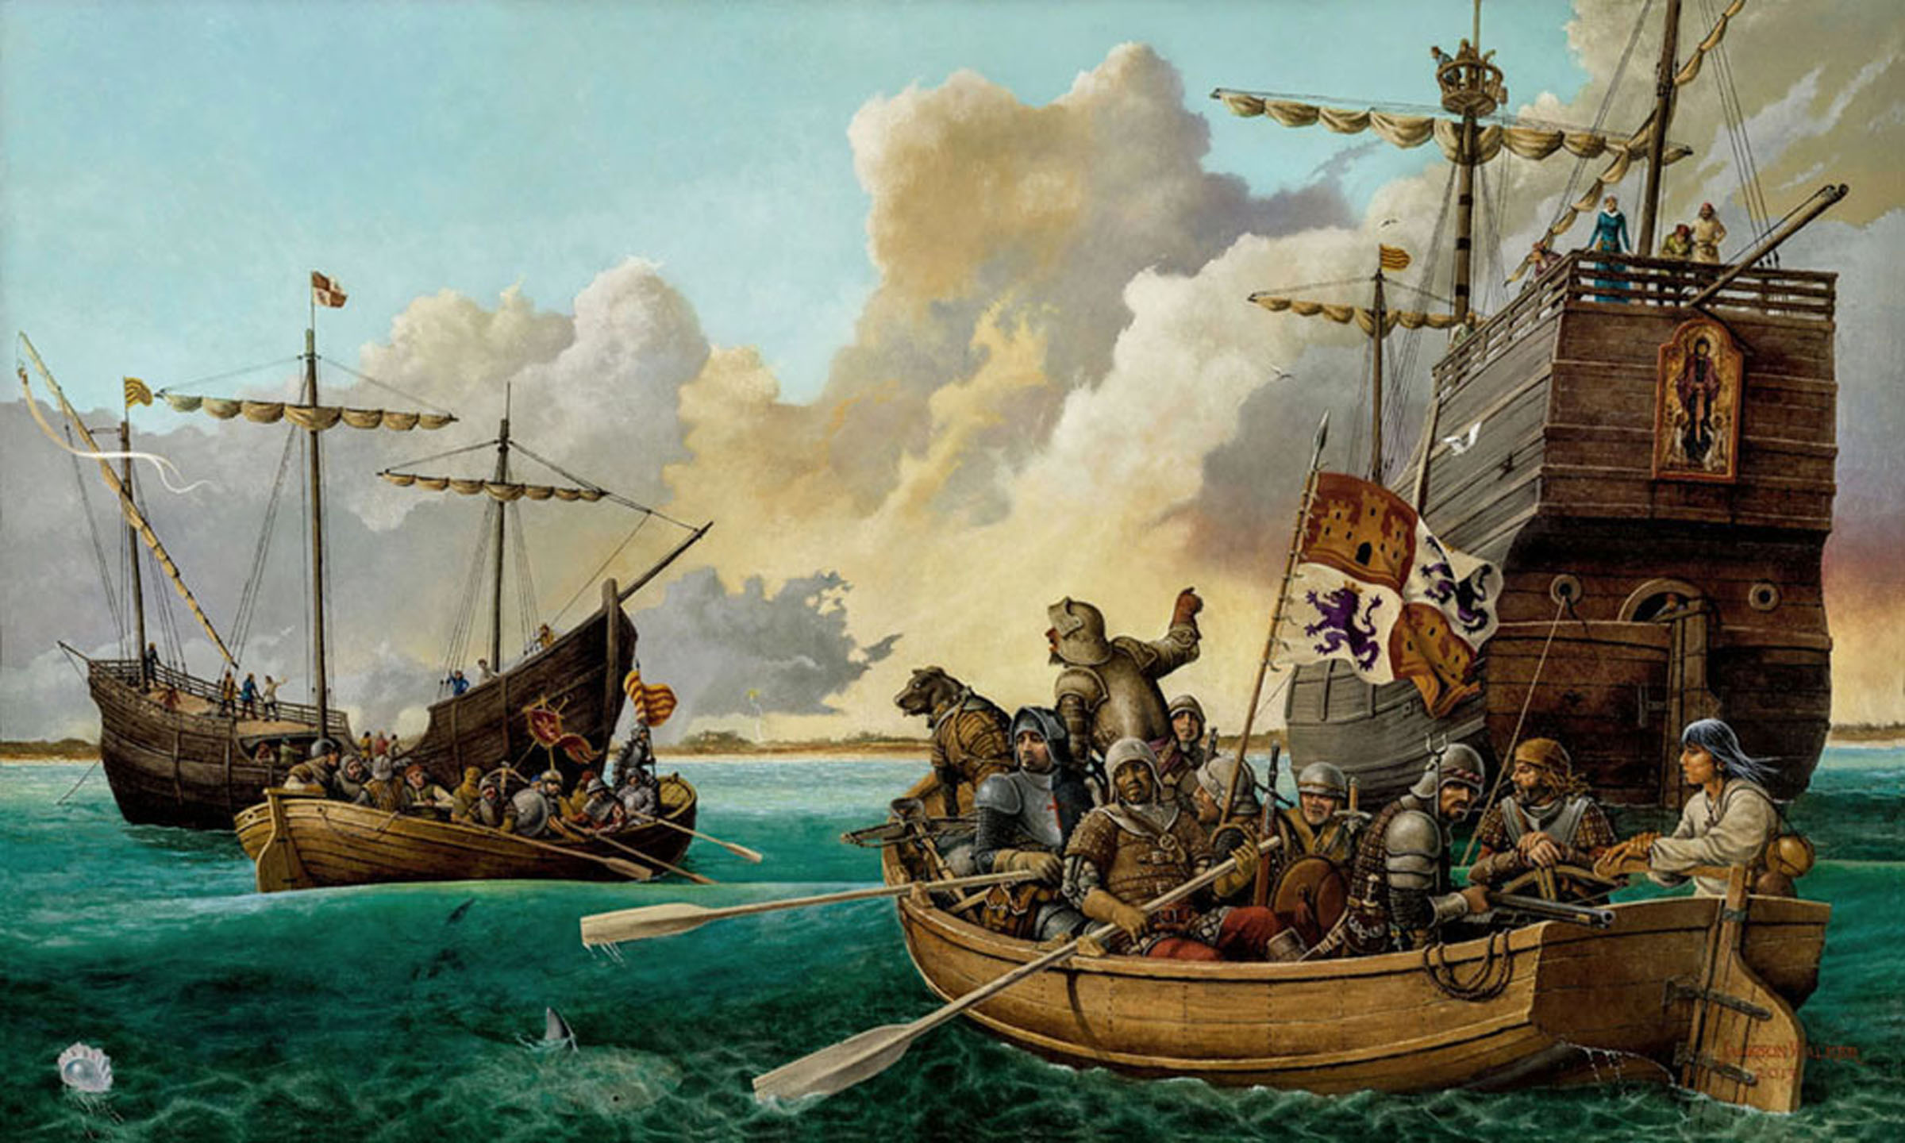1513-2013 Music and art turn the pages of 500 years of history! Students sail into the adventure of crossing oceans and sighting land with the orchestra and Ponce de Leon; land bursting with greenery and flowers of every color, ‘Pascua Florida’! They step into the gentle footprints of William Bartram to see his world through video and Jackson Walker’s incredible paintings and to feel Florida’s natural world through Robert Kerr’s wondrous music. On Board! Students hop Flagler’s amazing train for a final wild boogie-woogie ride across water to Key West!

Residency and Culminating Concert with Symphony
The Artist provides all narrations, images, costumes, and music for this exciting 45 minute program that expands the experiences of the classroom.

History is a subject about people who dared to live their lives courageously. It illuminates their triumphs, their shortcomings, and the unknown consequences of their actions.
We can learn how to better write our own life stories by knowing theirs.
Students experience dedicated orchestral musicians living their dreams!

Figures and Learning for Young Floridians
Juan Ponce de Leon: Spanish explorer who set foot on Florida in 1513
Identify the Families of Instruments in the Orchestra

Important Figures for Veteran Floridians
Pedro Menendez de Aviles: Established St. Augustine
Casillo de San Marcos: Fort in St. Augustine
Andrew Jackson: Helped secure Florida for the United States
Marjorie Kinnan Rawlings: Pulitzer Prize winner for ‘The Yearling’
William Bartram: Early conservationist
Henry Flagler: Built an ‘impossible’ railroad and opened the door to FL

According to FL historian Dr. Gary Mormino, one of the most important events in the history of Florida occurred sometime in the early 16th century. When Ponce de Leon first sighted land near present day Cape Canaveral in 1513, as many as 150,000 Natives lived in the place he christened La Florida. Natives had been living here for at least 10,000 years; tribes and peoples called Timucua, Apalachee, Pensacola, Calusa, Creek, and Tequesta. Tragically, they all lacked immunity to Old World diseases; many perished, yet their place names endure. Florida’s history, like America’s, is one of youthful energy. It is one of Spanish explorers and immigrants, of people still seeking the Fountain of Youth, of cowboys and those seeking frontiers in space. Within the boundaries of the state is the oldest occupied city in North America, as well as the launching site of the first manned trip to the moon. Ponce de Leon named the peninsula La Florida because it reminded him of the spanish ‘feast of flowers’. The poet Elizabeth Bishop rhapsodized that Florida is ‘the state with the prettiest name.’

Character Traits that created Florida
- Courage to explore 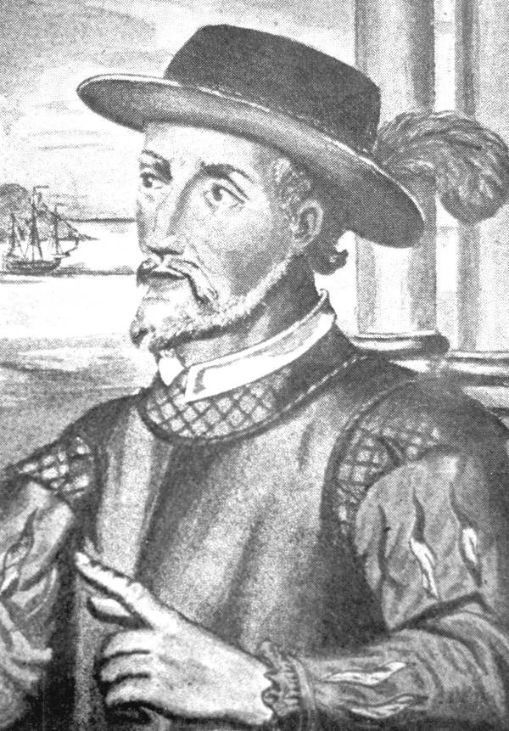
- Tenacity to persevere hardships for beliefs 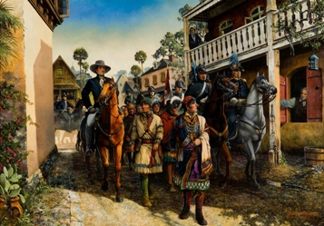
- Dedication to preserving natural beauty 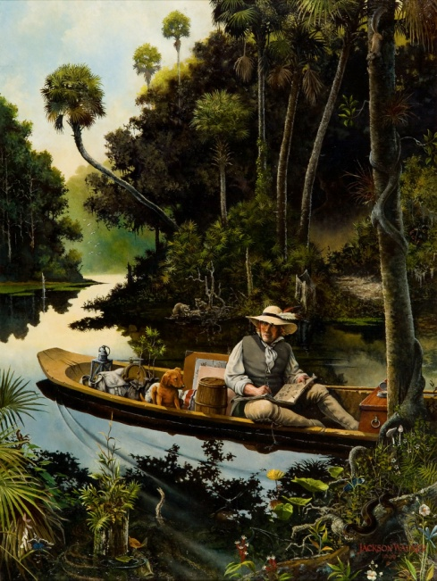
- Willingness to risk failure 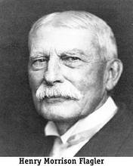

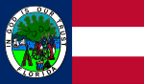

The flags of five countries have flown over Florida. Many people have influenced the extraordinary history of this State we call home.
COME! Journey with us!

SS.4.A.1 Historical Inquiry and Analysis
SS.4.A.3 Identify European Explorers and their effects on Florida
MU.4.3.2.3; MU.C.1.2.3; MU.E.1.2.2 Rhythm, meter, lyrics, historical context MU.4.H.3 Learn connections between learning music and learning other subjects
VA.4.C.3 Developing Critical Thinking Skills and Vocabulary for connection to other subject areas

